Algebra 1: Unit 13, Lesson 7

- A table of values for $R(x)=x^{2}$ is given.
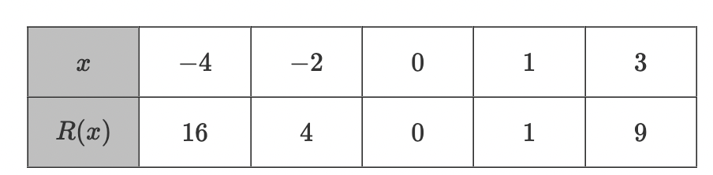
Complete the statement.
The $y$- values for the transformation, $R(x)={-4x}^{2}$, are __________________.
Multiplied by $-4$

- A table of values for the function, $B(x)=|x|,$ is given.
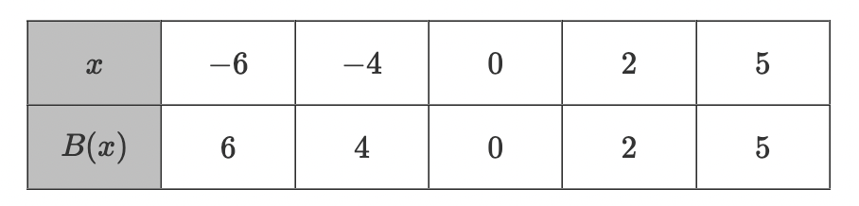
Complete the statement.
The coefficient of $B(x)=3|x|$ is _________________.
$$3$$

- A table of values for $K(x)=x$ and $T(x)=3x$ is given.
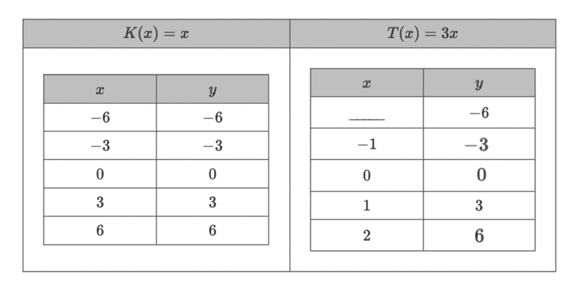
Complete the table of values for $T(x)$.
$$-2$$

